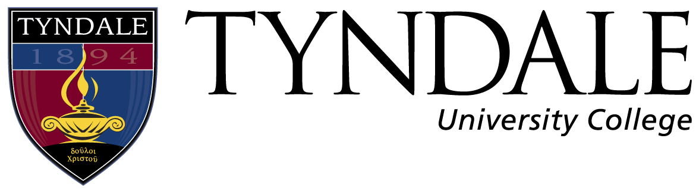
Exit Interview

Student Information

Student Name: _______________________
Student ID#: _______________________
Degree: _______________________
Faculty Advisor: _______________________
Semester: _______________________

Interview Questions

- What did you appreciate about your time at Tyndale?

- What did you not appreciate about your time at Tyndale?

- What are your plans for ‘life after Tyndale”?

______________________ _______________________
Faculty Advisors Signature Students Signature

