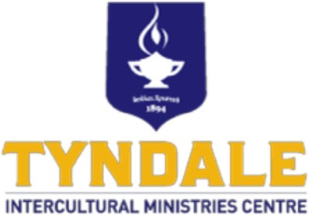
Course: Intercultural Communication
Thursdays, 7:30pm – 9:30pm
September 17 thru December 3, 2026

PROFESSOR:
Rev. Dr. Joseph Hong
joseph_hong@wycliffe.ca

GUEST SPEAKER:
Rev. Kwangyoung Park
TBD

COURSE DESCRIPTION

This course explores the nature of intercultural communication, examines the key elements that make it up, and focuses on learning and acquiring the attitude and skills for effective intercultural communication as a Christian. It also considers the contextualized biblical leadership that disciples of Christ who work in multicultural settings should have.

COURSE OBJECTIVES

Upon completion of this course, students should be able to:

1. Understand the basic elements and various aspects of intercultural communication.
2. Identify the main patterns of intercultural communication and analyze how these patterns affect intercultural communication.
3. Develop the ability to communicate interculturally.
4. Address the attitude of service for ministry in other cultures and reflect on their current service.
- COURSE SCHEDULE
Week | Date | Topics | Assignments | Professor
1 | Sep 18 | Intercultural Communication |  | Dr. Hong
2 | Sep 25 | Foundations of Intercultural Communication Patterns | Pre-class Reading: Today’s chapters from the text book  Post-class Reflection: Reflection on a selected topic from previous class | Dr. Hong
3 | Oct 2 | Non-verbal communication & Contexting | Same as above | Dr. Hong
4 | Oct 9 | Polychronic and Monochronic Time & Individualism and Collectivism | Same as above | Dr. Hong
5 | Oct 16 | Social Power in Intercultural Communication & Gender Roles & Honor and Justice | Same as above | Dr. Hong
6 | Oct 23 | Reading week (No class)
7 | Oct 30 | Special Lecture | No pre-class reading assignment. Only the post class reflection paper. | Rev. Park
8 | Nov 6 | Special Lecture | No pre-class reading assignment. Only the post class reflection paper. | Rev. Park
9 | Nov 13 | Intercultural Relationships & Intercultural Evangelism | Pre-class Reading: Today’s chapter from the text book  Post-class Reflection: Reflection on a selected topic from previous class | Dr. Hong
10 | Nov 20 | Intercultural Discipleship | Same as above | Dr. Hong
11 | Nov 27 | Intercultural Church Planting | Same as above | Dr. Hong
12 | Dec 4 | Intercultural Ministry through Teams  Final Exam | Same as above | Dr. Hong

- TEXT BOOKS
Primary Text
Moreau, A. Scott, Evvy Hay Campbell, Susan Greener. Effective Intercultural Communication: A Christian Perspective. Baker Academic. 2014
References
Duane Elmer, Cross-cultural Servanthood: Serving the World in Christlike Humility. IVP. 2006
Duane Elmer, Cross-cultural Connections: Stepping Out and Fitting In Around the World. IVP. 2002

ASSIGNMENTS AND GRADING GUIDELINE

Reading and class discussion – 20 % of Grade
    - Before come to class, read the chapter to be discussed
    - Discuss on the main arguments of the chapter

Personal Reflection Papers - 30 % of Grade
    - 1 page (single space, 12 font size) reflection paper on a selected topic discussed during the previous class. Students freely choose the topic to write a reflection on.

Final Exam - 50% of Grade
    - Students are given a list of questions to answer. It is an open book and open references exam.

